Homework for week 2, submission deadline 23:59 on Sunday night.
- Choose your own topics from following list or your own.
- Gut microbiota and metabolic disease
- Single-cell transcriptomics in cancer immunology
- Antibiotic resistance genomics
- Epigenetic regulation in neurological disorders
- Muscle regeneration and aging
- Proteomic biomarkers in MAFLD/MASH
Finish the following question section we covered in the class
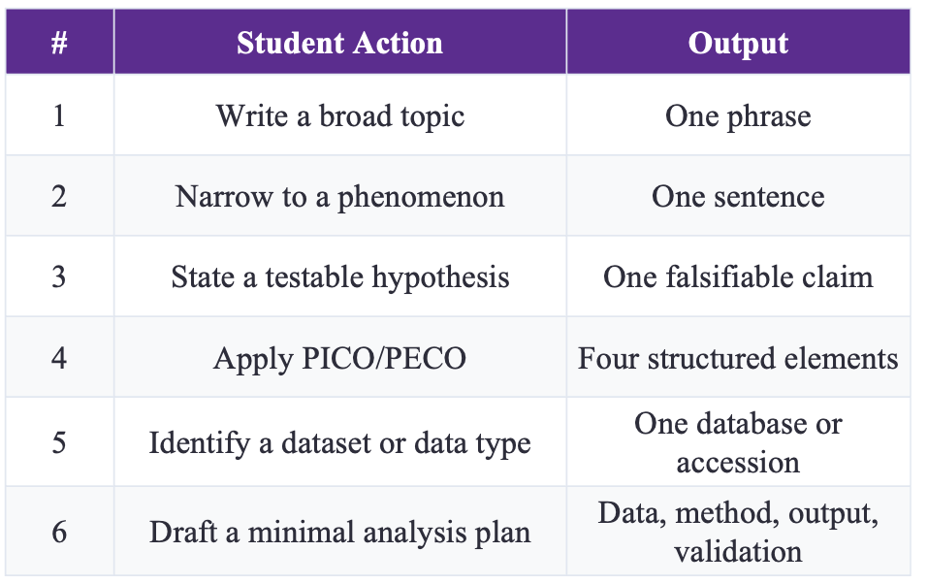
- Gut microbiota and metabolic disease
- In colorectal cancer (CRC), inflammatory bowel disease (IBD), and irritable bowel syndrome (IBS), specific mucosal gut microbial taxa are significantly associated with host colonic epithelial gene expression, and these association patterns exhibit both shared features across diseases and disease-specific differences.
- In CRC, IBD, and IBS, the same microbial taxa (e.g., Streptococcus, Peptostreptococcaceae) are associated with different host genes and pathways across the three diseases; conversely, the same host pathways (e.g., RAC1 pathway, oxidative phosphorylation) are associated with different microbial taxa across diseases. This indicates that microbe-host interactions are disease-context-dependent rather than following a pan-disease common pattern.

P (Population) | Colonic mucosal biopsy samples from patients with three diseases (CRC: n=44, IBD: n=56, IBS: n=29)
E (Exposure) | Disease status (CRC / IBD / IBS) and mucosal gut microbiome composition (16S rRNA sequencing)
C (Comparison) | Patients vs. healthy controls within each cohort; cross-comparison across the three diseases
O (Outcome) | 1. Significant host gene-microbe associations (count and direction)  2. Host pathways associated with microbiome (shared vs. disease-specific)  3. Different host genes associated with the same microbe across diseases
- Data type: Paired multi-omics data (host colonic mucosal transcriptome RNA-seq + 16S rRNA microbiome)
Data sources:
CRC: NCBI SRA PRJNA816986 (RNA-seq), PRJNA284355 (16S)
IBD: NCBI SRA PRJNA398089 (16S), GEO GSE111889 (RNA-seq)
IBS: NCBI SRA PRJEB37924 (16S), GEO GSE146853 (RNA-seq)
Processed data: Supplementary Tables S12–S17 provide ready-to-use expression matrices and OTU abundance tables
Data  数据 | Per disease cohort:  • Host gene expression matrix (12,000+ protein-coding genes)  • Microbial taxa abundance matrix (CRC: 235 taxa; IBD: 121; IBS: 238)  • Covariates: gender, disease subtype (IBD: CD/UC; IBS: IBS-C/IBS-D)
Method  方法 | 1. Group-level integration: Sparse CCA to identify correlations between host gene sets and microbial groups (FDR < 0.1)  2. Gene-microbe pairing: Lasso regression + stability selection to identify individual host gene-microbe associations (FDR < 0.1, selection frequency ≥ 60%)  3. Pathway enrichment: Fisher's exact test + Benjamini-Hochberg correction (FDR < 0.1) using MsigDB (KEGG, PID, REACTOME)  4. Cross-disease comparison: Overlap coefficient + comparative log odds-ratio analysis
Output  产出 | 1. List of significant host gene-microbe associations per disease (CRC: 755; IBD: 1,295; IBS: 441)  2. Shared vs. disease-specific host pathway lists (Fig. 2A)  3. Network of host genes associated with the same microbe across diseases (Fig. 4A)  4. Different microbes associated with the same host pathway across diseases (Fig. 2B)
Validation  验证 | 1. Case vs. control comparison: Retain only associations present in patients but not in controls to ensure disease specificity  2. Stability validation: Report only Lasso associations passing stability selection (100 resampling rounds, 60% threshold)  3. Statistical robustness: Desparsified lasso for 95% CIs and P-values with FDR correction  4. Cross-validation: Sparse CCA components validated by leave-one-out cross-validation

- Find and read two research papers in the folder and answer following question based on these two papers.
  - Question 1: Use the PICO/PECO, what are they for these two papers?
  - Question 2: What kind of dataset or data type these two papers use?
  - Question 3: What is the hypothesis of these two research?

Paper 1: A PRDM16-Driven Metabolic Signal from Adipocytes Regulates Precursor Cell Fate

a. PICO/PECO 分析 / PICO/PECO Analysis
要素 | Content (English)
P (Population) | Adipose precursor cells (stromal-vascular cells, SVCs) and mature adipocytes in inguinal white adipose tissue (iWAT) from young (2-month-old) and aged (12-month-old) mice
E (Exposure / Intervention) | Intervention: Cold exposure (4°C) or β3-adrenergic agonist CL316,243 (CL) treatment; PRDM16 overexpression (transgenic) or knockout.  Mechanistic exposure: Paracrine action of β-hydroxybutyrate (BHB) secreted by adipocytes on precursor cells; BDH1-mediated BHB catabolism
C (Comparison) | 1. Young vs. aged mice  2. PRDM16 transgenic vs. wild-type controls  3. PRDM16 knockout (Adipoq<sup>Cre</sup>Prdm16-KO) vs. wild-type controls  4. BHB-treated vs. vehicle-treated groups  5. PRDM16-CM (conditioned medium) vs. GFP-CM controls  6. Ketone ester (KE) diet vs. calorie-matched control diet
O (Outcome) | 1. Precursor cell fibrotic phenotype (ACTA2⁺ stress fibers, Col1a1/Col3a1/Acta2 mRNA)  2. Beige adipocyte differentiation (UCP1⁺ cells, lipid droplet formation, Pparg/Adipoq/Ucp1 expression)  3. Tissue collagen deposition (Picrosirius red staining quantification)  4. BHB secretion levels and BDH1-mediated ketone metabolism  5. Reversal of aging-induced fibrosis and restoration of beige fat development

b. Data Types and Datasets
Data Type | Specific Content
Transcriptomic data (RNA-seq) | Gene expression profiles of iWAT from young vs. aged mice with or without CL treatment (GEO: GSE129083, GSE129084)
Metabolomics data | LC-MS measurements of BHB, acyl-CoA, and TCA cycle intermediates in conditioned media and adipose tissues
Isotopic tracing data | ¹³C-palmitate labeling to track fatty acid oxidation (FAO) flux and BHB synthesis
Histological data | UCP1 immunofluorescence, Picrosirius red collagen staining, and H&E-stained tissue sections
Flow cytometry data | Quantitative analysis of tdTomato and PLIN1 co-localization in PDGFRα⁺ precursor cells
Protein expression data (Western blot) | Protein levels of PRDM16, PPARγ, HIF1α, ACTA2, and others

c. Hypothesis
The transcription factor PRDM16 in adipocytes drives fatty acid oxidation and ketogenesis, promoting the secretion of β-hydroxybutyrate (BHB). BHB acts in a paracrine manner on adipose precursor cells via BDH1-mediated ketone catabolism to suppress HIF1α/TGFβ-induced myofibroblast differentiation (fibrosis) while promoting beige adipocyte differentiation. Aging impairs this signaling axis by reducing PRDM16 expression, leading to adipose fibrosis and defective beige fat development; elevating PRDM16 or BHB levels reverses these aging-associated defects.

Paper 2: Identification of shared and disease-specific host gene-microbiome associations across human diseases using multi-omic integration (Nature Microbiology, 2022)

a. PICO/PECO Analysis
Element | Content
P (Population) | Colonic mucosal biopsy samples from patients with colorectal cancer (CRC, n=44 patients, 88 paired samples), inflammatory bowel disease (IBD, n=56 patients, 78 samples), and irritable bowel syndrome (IBS, n=29 patients, 42 samples)
E (Exposure) | Disease status (CRC, IBD, IBS vs. respective controls); mucosal gut microbiome composition (16S rRNA sequencing) and its association with host gene expression
C (Comparison) | Patients vs. healthy controls within each disease cohort; cross-comparison across the three diseases (shared vs. disease-specific associations); differential enrichment analysis between cases and controls
O (Outcome) | Significant and stability-selected host gene-microbe associations (lasso regression + stability selection, FDR < 0.1); host pathways associated with microbiome composition (sparse CCA, FDR < 0.1); shared vs. disease-specific host pathways and microbial taxa; specific microbes (e.g., Streptococcus, Peptostreptococcaceae) associated with different host genes in different diseases

b. Data Types and Datasets
Data Type | Specific Content
Host transcriptomic data (RNA-seq) | Host gene expression count matrices from colonic mucosal biopsies (CRC: 12,513 genes; IBD: 11,985 genes; IBS: 12,429 genes)
Gut microbiome data (16S rRNA sequencing) | Operational taxonomic unit (OTU) abundance tables of mucosa-associated microbiota (CRC: 235 taxa; IBD: 121 taxa; IBS: 238 taxa)
Clinical metadata | Covariates including sex, disease subtype (IBD: CD/UC; IBS: IBS-C/IBS-D), and age
Public databases | NCBI SRA (PRJNA816986, PRJNA284355, PRJNA398089, PRJEB37924), GEO (GSE111889, GSE146853), MsigDB (KEGG, PID, REACTOME pathway collections)

c. Hypothesis
In colorectal cancer (CRC), inflammatory bowel disease (IBD), and irritable bowel syndrome (IBS), there are statistically significant associations between specific mucosal gut microbial taxa and host colonic epithelial gene expression. These associations include both shared patterns across diseases (involving common pathways of gastrointestinal inflammation, gut barrier protection, and energy metabolism) and disease-specific patterns (e.g., tumorigenesis pathways in CRC, immunoinflammatory pathways in IBD, and gut homeostasis pathways in IBS). The same microbial taxon may affect different pathophysiological processes in different diseases by regulating distinct host genes.

- Based on your research interest, refine the search in PUBMED, and sort, identify the latest and the most important studies in your field. Read this paper and answer three questions:
  - Question 1: Use the PICO/PECO, what are they for these two papers?
  - Question 2: What kind of dataset or data type these two papers use?
  - Question 3: What is the hypothesis of these two research?

Paper 1: Engineered Probiotic for Hyperuricemia Management
Full DOI: 10.1080/19490976.2024.2399213
Journal & Year: Gut Microbes, 2024

a. PICO/PECO Analysis
Element | Content
P (Population) | Murine model of hyperuricemia; reference to human clinical context
E (Exposure) | Engineered probiotic Escherichia coli Nissle 1917 strain (YES301) designed with a high-efficiency xanthine importer (XanQ)
C (Comparison) | Conventional uric acid-lowering drug (allopurinol); untreated hyperuricemic controls
O (Outcome) | Serum uric acid concentration; renal function improvement; therapeutic efficacy; adverse effect profile; biosafety

b. Data Types and Datasets
Data Type | Specific Content
In vivo efficacy data | Serum uric acid measurements in hyperuricemic murine models
Renal function data | Biomarkers indicating amelioration of renal impairment
Safety/toxicity data | Adverse effect profiles compared to allopurinol treatment
Pharmacodynamic data | Mechanism of action through intestinal purine uptake and reduction

c. Hypothesis
Engineered probiotic E. coli Nissle 1917 (YES301) with enhanced xanthine and hypoxanthine transport capacity can effectively reduce serum uric acid levels and ameliorate renal impairments in hyperuricemia, achieving therapeutic efficacy comparable to allopurinol while offering a superior safety profile .

